Anti-Vacuolar Zn2+/H+ antiporter antibody
Catalog: PHY0186S

Product Information

Description: | Rabbit polyclonal antibody
Background: | MTP1 is localized to the vacuolar membrane, it is mediating zinc accumulation in roots and resistance to zinc.
Synonyms: | MTP1, A. THALIANA CATION DIFFUSION FACILITATOR 1, ATCDF1, ATMTP1, METAL TOLERANCE PROTEIN 1, MTP1, OVERLY ZINC SENSITIVE 1, OZS1, ZAT, ZAT1, ZINC TRANSPORTER OF ARABIDOPSIS THALIANA, ZINC TRANSPORTER OF ARABIDOPSIS THALIANA 1
Immunogen: | KLH-conjugated synthetic peptide (16 aa from Central section) derived from Arabidopsis thaliana MTP1 (AT2G46800).
Form: | Lyophilized
Quantity: | 150 µg
Purification: | Serum  Peptide affinity form antibody available upon request at info@phytoab.com.
Reconstitution: | Reconstitution with 150 µl of sterile water.  "Note: please spin tube briefly prior to opening it to avoid any losses that might occur from lyophilized material adhering to the cap or sides of the tube".
Stability & Storage: | Use a manual defrost freezer and avoid repeated freeze-thaw cycles.  12 months from date of receipt, -20 to -70℃ as supplied.  6 months, -20 to -70℃ under sterile conditions after reconstitution.  1 month, 2 to 8℃ under sterile conditions after reconstitution.
Shipping: | The product is shipped at 4℃. Upon receipt, store it immediately at the temperature recommended above.

Application Information

Recommended Dilution: | Western Blot (1:1000-1:2000)  Note: Optimal dilutions/concentrations should be determined by the end user.
Expected / apparent MW: | 44 kDa
Predicted Reactivity: | Among species analyzed, the sequence of the synthetic peptide used for immunization is 80-99% homologues with the sequence in Brassica napus, Brassica rapa.  For more species homologues information, please contact tech support at tech@phytoab.com.

Application Example
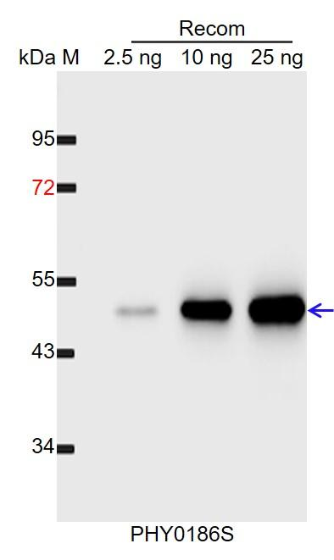
Recom: 2.5 ng, 10 ng and 25 ng recombinant protein containing the peptide for immunization and having a molecular mass of 52 kDa.
Electrophoresis: 12% SDS-PAGE
Transfer: blotting to NC (nitrocellulose) membrane for 1 h.
Blocking: 5% skim milk at RT or 4℃ for 1 h.
Primary antibody: 1:1000 dilution overnight at 4℃.
Secondary antibody: 1:10000 dilution using Goat Anti-Rabbit IgG H&L (HRP) (Cat# PHY6000).
Detection: using chemiluminescence substrate and image were captured with CCD camera.

